A PROJECT REPORT ON

“GENETIC OPTIMIZATION FOR FEATURE SELECTION”

SUBMITTED TO THE SAVITRIBAI PHULE PUNE UNIVERSITY, PUNE

SUBMITTED BY

Aniruddh Sanjeev Bhagwat | Roll No: 405B005
Chouhan Manav Kamlesh | Roll No: 405B018
Kshirsagar Rohit Suryakant | Roll No: 405B036
Prashant Kumar | Roll No: 405B049



DEPARTMENT OF COMPUTER ENGINEERING

SINHGAD COLLEGE OF ENGINEERING, PUNE-41

SAVITRIBAI PHULE PUNE UNIVERSITY

2020 - 21

CERTIFICATE

This is to certify that the project report entitles

“GENETIC OPTIMIZATION FOR FEATURE SELECTION”

Submitted by

Aniruddh Sanjeev Bhagwat Exam No : B150234217
Chouhan Manav Kamlesh Exam No : B150234246
Kshirsagar Rohit Suryakant Exam No : B150234297
Prashant Kumar Exam No : B150234347

is a bonafide work carried out by him under the supervision of Prof. Praveen Kamde and it is approved for the partial fulfillment of the requirement of University of Pune as a part of Laboratory Practice IV work syllabus (Final year Computer Engineering).

(………... ……………… ) | (. ……………… )
Prof.Praveen Kamde  Subject In-charge | Prof.M.P.Wankhade  Head, Department of Computer Engineering

ACKNOWLEDGEMENT

It is indeed a great pleasure and moment of immense satisfaction for we to present a project report on “Genetic optimization for feature selection” amongst a wide panorama that provided us inspiring guidance and encouragement, we take the opportunity to thanks those who gave us their in debted assistance. We wish to extend our cordial gratitude with profound thanks to our internal guide Prof. Praveen Kamde for his everlasting guidance. It was his inspiration and encouragement which helped us in completing our project.
Our sincere thanks and deep gratitude to Head of Department, M. P. Wankhade and other faculty member; but also to all those individuals involved both directly and indirectly for their help in all aspect of the project. At last but not least we express our sincere thanks to our Institute’s Principal Dr. S.D. Lokhande, for providing us infrastructure and technical environment.

Aniruddh Sanjeev Bhagwat
Manav Kamlesh Chouhan
Rohit Suryakant Kshirsagar
Prashant Kumar

ABSTRACT

Genetic Algorithms(GAs) are adaptive heuristic search algorithms that belong to the larger part of evolutionary algorithms. Genetic algorithms are based on the ideas of natural selection and genetics. These are intelligent exploitation of random search provided with historical data to direct the search into the region of better performance in solution space. They are commonly used to generate high-quality solutions for optimization problems and search problems.
Genetic algorithms simulate the process of natural selection which means those species who can adapt to changes in their environment are able to survive and reproduce and go to next generation. In simple words, they simulate “survival of the fittest” among individual of consecutive generation for solving a problem. Each generation consist of a population of individuals and each individual represents a point in search space and possible solution. Each individual is represented as a string of character/integer/float/bits. This string is analogous to the Chromosome.
We have used personal cloud storage and encrypted it with AES algorithm to ensure security. This cloud can be accessed anywhere. The cloud storage works on raspberry pi based system.

CONTENTS

CHAPTER |  | TITLE | PAGE NO
01 |  | Problem Statement Definition | 1
02 |  | Software Requirements Specification | 1
 | 2.1 | Introduction | 1
 | 2.2 | Scope | 4
03 |  | System Implementation and Source Code | 4
04 |  | Conclusion | 10
05 |  | References | 10

1. Problem Definition
Apply the Genetic Algorithm for optimization on a dataset obtained from UCI ML repository.

2. Software Requirements and Specification
- Jupyter /Spyder/ Python Compiler
- Diabetes DataSet
- Genetic algorithm
- Personal Cloud Storage
2.1 Introduction
2.1.1 Genetic algorithm
Genetic Algorithms(GAs) are adaptive heuristic search algorithms that belong to the larger part of evolutionary algorithms. Genetic algorithms are based on the ideas of natural selection and genetics. These are intelligent exploitation of random search provided with historical data to direct the search into the region of better performance in solution space. They are commonly used to generate high-quality solutions for optimization problems and search problems.
Genetic algorithms simulate the process of natural selection which means those species who can adapt to changes in their environment are able to survive and reproduce and go to next generation. In simple words, they simulate “survival of the fittest” among individual of consecutive generation for solving a problem. Each generation consist of a population of individuals and each individual represents a point in search space and possible solution. Each individual is represented as a string of character/integer/float/bits. This string is analogous to the Chromosome.

2.1.2GA Algorithm
The basic structure of a GA is as follows −
We start with an initial population (which may be generated at random or seeded by other heuristics), select parents from this population for mating. Apply crossover and mutation operators on the parents to generate new off-springs. And finally these off-springs replace the existing individuals in the population and the process repeats. In this way genetic algorithms actually try to mimic the human evolution to some extent.

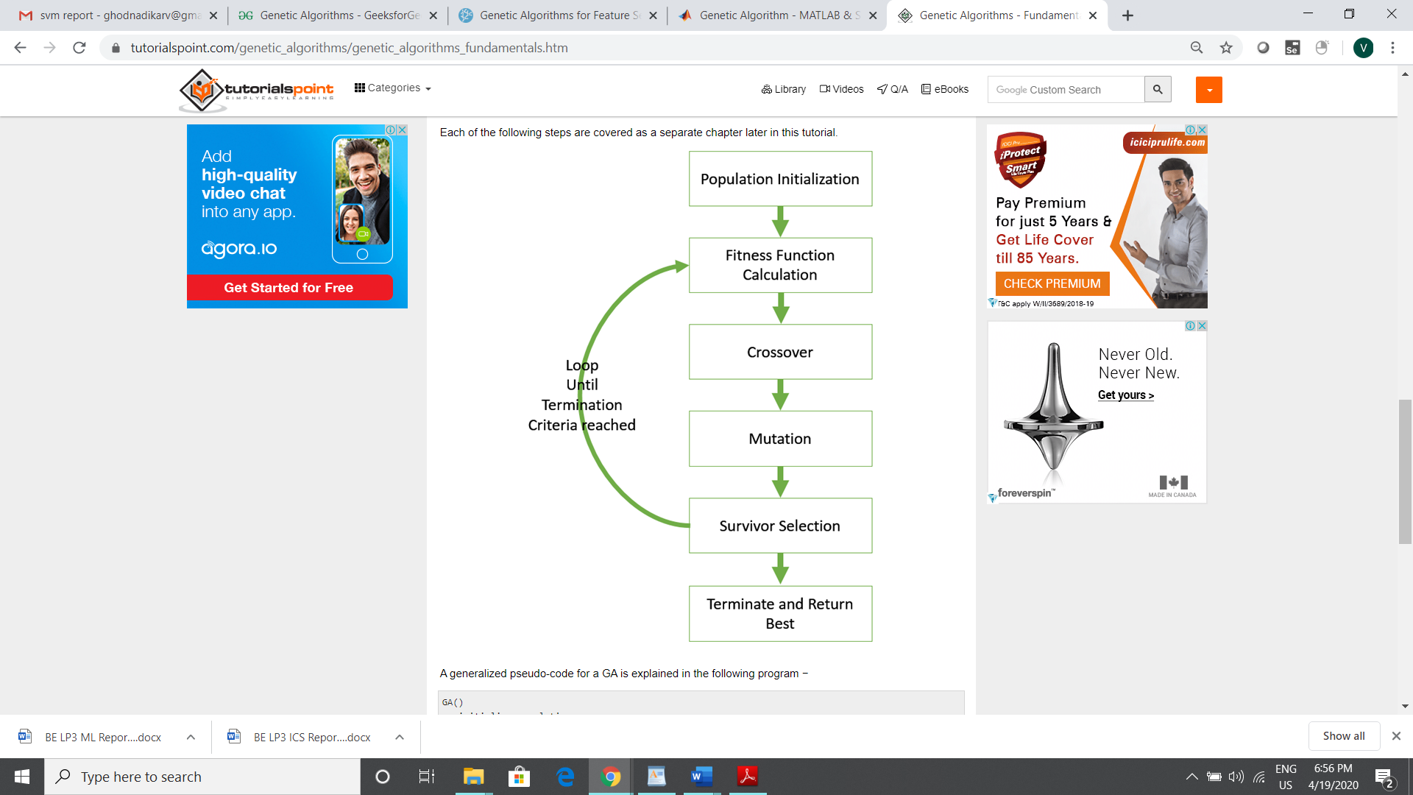
Fig: Genetic Algorithm

Population initialization:
There are two primary methods to initialize a population in a GA. They are −
- Random Initialization − Populate the initial population with completely random solutions.
- Heuristic initialization − Populate the initial population using a known heuristic for the problem.
It has been observed that the entire population should not be initialized using a heuristic, as it can result in the population having similar solutions and very little diversity. It has been experimentally observed that the random solutions are the ones to drive the population to optimality. Therefore, with heuristic initialization, we just seed the population with a couple of good solutions, filling up the rest with random solutions rather than filling the entire population with heuristic based solutions.
It has also been observed that heuristic initialization in some cases, only effects the initial fitness of the population, but in the end, it is the diversity of the solutions which lead to optimality.

- Fitness Function
The fitness function simply defined is a function which takes a candidate solution to the problem as input and produces as output how “fit” our how “good” the solution is with respect to the problem in consideration.Calculation of fitness value is done repeatedly in a GA and therefore it should be sufficiently fast. A slow computation of the fitness value can adversely affect a GA and make it exceptionally slow.In most cases the fitness function and the objective function are the same as the objective is to either maximize or minimize the given objective function. However, for more complex problems with multiple objectives and constraints, an Algorithm Designer might choose to have a different fitness function.
- Crossover
The crossover operator is analogous to reproduction and biological crossover. In this more than one parent is selected and one or more off-springs are produced using the genetic material of the parents. Crossover is usually applied in a GA with a high probability – p_{c} .

- Mutation
In simple terms, mutation may be defined as a small random tweak in the chromosome, to get a new solution. It is used to maintain and introduce diversity in the genetic population and is usually applied with a low probability – p_{m}. If the probability is very high, the GA gets reduced to a random search.
Mutation is the part of the GA which is related to the “exploration” of the search space. It has been observed that mutation is essential to the convergence of the GA while crossover is not.

- Survivor selection
The Survivor Selection Policy determines which individuals are to be kicked out and which are to be kept in the next generation. It is crucial as it should ensure that the fitter individuals are not kicked out of the population, while at the same time diversity should be maintained in the population.
Some GAs employ Elitism. In simple terms, it means the current fittest member of the population is always propagated to the next generation. Therefore, under no circumstance can the fittest member of the current population be replaced.
The easiest policy is to kick random members out of the population, but such an approach frequently has convergence issues, therefore the following strategies are widely used.

- Terminate
The termination condition of a Genetic Algorithm is important in determining when a GA run will end. It has been observed that initially, the GA progresses very fast with better solutions coming in every few iterations, but this tends to saturate in the later stages where the improvements are very small. We usually want a termination condition such that our solution is close to the optimal, at the end of the run.
Usually, we keep one of the following termination conditions −
- When there has been no improvement in the population for X iterations.
- When we reach an absolute number of generations.
- When the objective function value has reached a certain pre-defined value.

2.1.3 Cloud Computing
Cloud computing is the delivery of different services through the Internet. These resources include tools and applications like data storage, servers, databases, networking, and software.
Rather than keeping files on a proprietary hard drive or local storage device, cloud-based storage makes it possible to save them to a remote database. As long as an electronic device has access to the web, it has access to the data and the software programs to run it. Cloud computing is a popular option for people and businesses for a number of reasons including cost savings, increased productivity, speed and efficiency, performance, and security.
Cloud computing is named as such because the information being accessed is found remotely in the cloud or a virtual space. Companies that provide cloud services enable users to store files and applications on remote servers and then access all the data via the Internet. This means the user is not required to be in a specific place to gain access to it, allowing the user to work remotely
Types of Cloud Services
Regardless of the kind of service, cloud computing services provide users with a series of functions including:
- Email
- Storage, backup, and data retrieval
- Creating and testing apps
- Analyzing data
- Audio and video streaming
- Delivering software on demand
Types of Cloud Computing
Cloud computing is not a single piece of technology like a microchip or a cellphone. Rather, it's a system primarily comprised of three services: software-as-a-service (SaaS), infrastructure-as-a-service (IaaS), and platform-as-a-service (PaaS).
- Software-as-a-service (SaaS) involves the licensure of a software application to customers. Licenses are typically provided through a pay-as-you-go model or on-demand. This type of system can be found in Microsoft Office's 365.¹﻿
- Infrastructure-as-a-service (IaaS) involves a method for delivering everything from operating systems to servers and storage through IP-based connectivity as part of an on-demand service. Clients can avoid the need to purchase software or servers, and instead procure these resources in an outsourced, on-demand service. Popular examples of the IaaS system include IBM Cloud and Microsoft Azure.²﻿ ³﻿
- Platform-as-a-service (PaaS) is considered the most complex of the three layers of cloud-based computing. PaaS shares some similarities with SaaS, the primary difference being that instead of delivering software online, it is actually a platform for creating software that is delivered via the Internet. This model includes platforms like Salesforce.com and Heroku.
Personal Cloud Storage
A form of cloud storage that applies to storing an individual s data in the cloud and providing the individual with access to the data from anywhere. Personal cloud storage also often enables syncing and sharing stored data across multiple devices such as mobile phones and tablet computers. Personal cloud storage is also frequently referred to as mobile cloud storage or pocket cloud storage.
Apple’s iCloud, Google Drive, Windows SkyDrive and Amazon’s Simple Storage Service (Amazon S3) are currently the most popular examples of personal cloud storage. Hard drive manufacturers are increasingly providing personal cloud storage services as well via offerings like the Western Digital MyBook Live and Seagate GoFlex lines of hard drives.
2.2 Scope
The scope of this project is to optimize the results and find global maxima.
3. System Implementation and Source Code
INPUT:
import random
import numpy as np
import matplotlib.pyplot as plt
from sklearn.datasets import load_diabetes
from sklearn.model_selection import cross_val_score
from sklearn.linear_model import LinearRegression

class GeneticAlgorithm():
def __init__(self, estimator, n_gen, size, n_best, n_rand, n_children, mutation_rate):
self.estimator = estimator
self.n_gen = n_gen
self.size = size
self.n_best = n_best
self.n_rand = n_rand
self.n_children = n_children
self.mutation_rate = mutation_rate

if int((self.n_best + self.n_rand) / 2) * self.n_children != self.size:
raise ValueError("The population size is not stable.")

def start(self):
dataset = load_diabetes()
X, y = dataset.data, dataset.target
#features = dataset.feature_names
est = LinearRegression()
score = -1.0 * cross_val_score(est, X, y, cv=5, scoring="neg_mean_squared_error")
print("Mean Squared Error before feature selection: {:.4f}".format(np.mean(score)))
print("Fittest Individual score for each generation:")
self.chromosomes_best = []
self.scores_best, self.scores_avg = [], []

self.dataset = X, y
self.n_features = X.shape[1]

population = self.initilizepopulation()
for i in range(self.n_gen):
population = self.generation(population)

score = -1.0 * cross_val_score(est, X[:,s.support_], y, cv=5, scoring="neg_mean_squared_error")
print("Mean Squared Error after feature selection: {:.2f}".format(np.mean(score)))

return self

def generation(self, population):

scores_sorted, population_sorted = self.fitnessscore(population)
population = self.selection(population_sorted)
population = self.crossover(population)
population = self.mutation(population)

self.chromosomes_best.append(population_sorted[0])
self.scores_best.append(scores_sorted[0])
self.scores_avg.append(np.mean(scores_sorted))

print(self.scores_best)

return population

def initilizepopulation(self):
population = []
for i in range(self.size):
chromosome = np.ones(self.n_features, dtype=np.bool)
mask = np.random.rand(len(chromosome)) < 0.3
chromosome[mask] = False
population.append(chromosome)
return population

def fitnessscore(self, population):
X, y = self.dataset
scores = []
for chromosome in population:
score = -1.0 * np.mean(cross_val_score(self.estimator, X[:,chromosome], y, cv=5,scoring="neg_mean_squared_error"))
scores.append(score)
scores, population = np.array(scores), np.array(population)
inds = np.argsort(scores)
return list(scores[inds]), list(population[inds,:])

def selection(self, population_sorted):
population_next = []
for i in range(self.n_best):
population_next.append(population_sorted[i])
for i in range(self.n_rand):
population_next.append(random.choice(population_sorted))
random.shuffle(population_next)
return population_next

def crossover(self, population):
population_next = []
for i in range(int(len(population)/2)):
for j in range(self.n_children):
chromosome1, chromosome2 = population[i], population[len(population)-1-i]
child = chromosome1
mask = np.random.rand(len(child)) > 0.5
child[mask] = chromosome2[mask]
population_next.append(child)
return population_next

def mutation(self, population):
population_next = []
for i in range(len(population)):
chromosome = population[i]
if random.random() < self.mutation_rate:
mask = np.random.rand(len(chromosome)) < 0.05
chromosome[mask] = False
population_next.append(chromosome)
return population_next

@property
def support_(self):
return self.chromosomes_best[-1]

def plot_graph(self):
ax = plt.axes()

ax.set_facecolor("black")
plt.plot(self.scores_best, label='Fittest')
plt.plot(self.scores_avg, label='Mean')
plt.legend()
plt.ylabel('Score Difference')
plt.xlabel('Generation')
plt.show()

s = GeneticAlgorithm(estimator=LinearRegression(),n_gen=7, size=200, n_best=40, n_rand=40,n_children=5, mutation_rate=0.05)
s.start()
s.plot_graph()

SEED = 2018
random.seed(SEED)
np.random.seed(SEED)
OUTPUT:
Mean Squared Error before feature selection: 2993.0729
Fittest Individual score for each generation:
[2950.546753971768]
[2950.546753971768, 2950.546753971768]
[2950.546753971768, 2950.546753971768, 2947.8230470393273]
[2950.546753971768, 2950.546753971768, 2947.8230470393273, 2947.8230470393273]
[2950.546753971768, 2950.546753971768, 2947.8230470393273, 2947.8230470393273, 2947.8230470393273]
[2950.546753971768, 2950.546753971768, 2947.8230470393273, 2947.8230470393273, 2947.8230470393273, 2944.892106107348]
[2950.546753971768, 2950.546753971768, 2947.8230470393273, 2947.8230470393273, 2947.8230470393273, 2944.892106107348, 2944.892106107348]
Mean Squared Error after feature selection: 2947.82

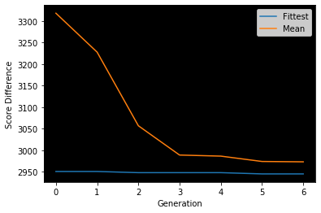

Personal Cloud Implementation

Code for uploading files in Personal Cloud
def uploadfile(subpath):
try:
if request.method == 'POST':
if 'files[]' not in request.files:
return redirect(request.url)
files = request.files.getlist('files[]')
encryptFile = request.form.getlist('encrypt')
for file in files:
if file and allowed_file1(file.filename):
filename = secure_filename(file.filename)
filename = gen_file_name1(filename)
file.save(os.path.join(subpath, filename))
if(encryptFile):
pyAesCrypt.encryptFile(os.path.join(subpath, filename), os.path.join(subpath, filename+".aes"), password)
os.remove(os.path.join(subpath, filename))
return jsonify({'message':'Uploaded'})
except:
return jsonify({'message':'Not able to upload'})

Code for downloading files from Personal Cloud

def downloadfile(name1,subpath):
path = subpath.split('/')
filename = path[-1]
name, extension = os.path.splitext(filename)
print(name, extension)
path = '/'.join(path[:-1])
if not extension:
file_paths = get_all_file_paths(subpath)
with ZipFile('Files.zip','w') as zip:
for file in file_paths:
os.chdir(file[:20])
zip.write(file[20:])
os.chdir("../../../")
source = os.path.join(os.getcwd(),'Files.zip')
destination = os.path.join(session['FILE_ROOT_DIR'],'Files.zip')
shutil.move(source, destination)
print('All files zipped successfully!')
return send_from_directory(session['FILE_ROOT_DIR'], "Files.zip", as_attachment=True)
if extension == '.aes':
pyAesCrypt.decryptFile(os.path.join(path,filename), os.path.join(path,filename[:-4]), password)
filename = filename[:-4]
source = os.path.join(path,filename)
destination = os.path.join(session['ENCRYPTED'],filename)
shutil.move(source, destination)
return send_from_directory(session['ENCRYPTED'], filename, as_attachment=True)
return send_from_directory(path, filename, as_attachment=True)

4. Conclusion
Hence, we developed genetic algorithm, in order to minimize optimization problems

5.References
- https://dkopczyk.quantee.co.uk/genetic-algorithm/
- https://www.tutorialspoint.com/genetic_algorithms/genetic_algorithms_quick_guide.htm
- https://www.geeksforgeeks.org/genetic-algorithms/

